**BHUTAN NATIONAL BANK LTD**



**DELEGATION OF AUTHORITY**

**2019**

Table of Contents

A. Preamble 2

B. Name of the Policy 2

C. Purpose of the policy 2

D. Scope of the policy 2

E. Organogram of the Bank 3

F. Power Reserved for the Board 3

G. Power Delegated to the Management 4

H. Elements of Delegation 4

I. Signature Rights 5

J. Guidelines for Implementation 5

1. Interpretation 5

2. Authority Levels 5

3. Abbreviations & Definitions 6

4. Institution of Committees 7

5. General Provisions 7

6. Financial Limits in the Delegation of Authority 9

7. The Procurement Process 9

8. Conflict of Interest 9

K. Schedule of Authorities 9

# Preamble

Delegation of Authority (DoA) refers to the grant of authority to various positions within an organisation, in this case the Bhutan National Bank Ltd (BNBL). A clear definition of the grant of power of various natures to different positions/officials at BNBL is necessary to expedite the implementation of policies and activities of the Bank. It also facilitates the process of making decisions based on rules and procedures and delineates accountability and responsibility for decisions and actions taken by officials. Delegation of power is also an integral part of the shared and distributed leadership in a company.

# Name of the Policy

This Policy shall be known as the Delegation of Authority 2019.

# Purpose of the policy

This Policy has been approved by the Board to:

* Set out authority related to the various functions delegated to the various levels of BNBL Management
* Set out authority reserved for specific positions in the Bank
* Establish expense approval limit for the various positions in the Bank

# Scope of the policy

The delegation of authority is based on the approved organizational structure of BNBL. Whenever there is a change in the structure of the organisation, these authorities shall be reviewed and updated accordingly.

The authority of the Board to delegate power has been drawn from clause 155 of the Companies Act of Bhutan 2016 and from relevant sections of the Articles of Incorporation of the Bank.

This Policy, particularly the Schedule of Authority, is subject to ongoing review to ensure that it remains relevant always.

The Policy shall apply to all employees of the Bank.

This policy shall be read in conjunction with, among others, the following:

i) Credit Policy of the Bank

ii) Banking SOPs

iii) HR Policy of the Bank

iv) Procurement Manual of the Bank

v) Business Code of Ethics

# Organogram of the Bank

The current organogram of the Bank is shown below:

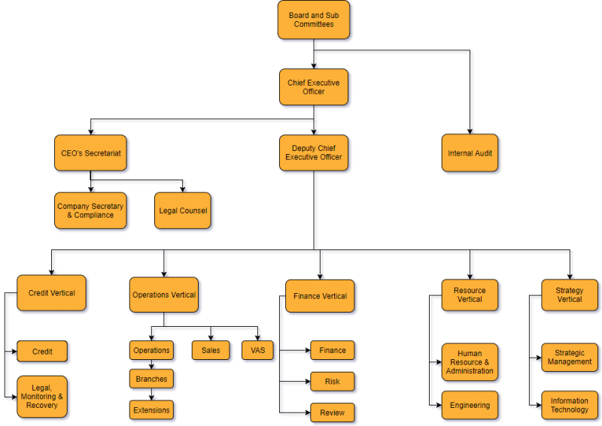

# Power Reserved for the Board

Matters specifically reserved for the Board include:

* Decisions about the Bank’s strategic direction and policies
* Matters involving financial amounts above the limits defined in the Schedule of Authorities
* Approval of contracts and procurements above the limits specified in the Schedule of Authorities
* Recruitment and remuneration of positions at the executive level
* Approval of annual budget
* All matters with the potential to have material impact on the reputation of the Bank

# Power Delegated to the Management

Other than as expressly provided in this policy, all matters not specifically reserved for the Board and necessary for the day-to -day management of the Bank, and the implementation of corporate objectives, are delegated to the management. The Bank’s policies and procedures shall guide the execution of specific roles and responsibilities.

Management shall:

* Ensure that the Bank’s day to day operations are carried out in accordance with all legal and regulatory requirements
* Ensure that the Bank’s polices, practices and decisions are undertaken in a manner that is prudent, equitable and consistent with commonly accepted business practices, integrity and professional ethics
* Ensure that the Bank’s assets are protected, adequately maintained and not placed at unnecessary risk
* Ensure that adequate measures are taken for the proper maintenance and safe custody of all financial records against loss, misplacement, mishandling, defacing and mutilation.
* Ensure that Board approved priorities are reflected in the allocation of resources
* Ensure a healthy work environment for staff that is consistent with the Bank’s values
* Represent the Bank externally among the shareholders, community, government, media and other stakeholders in ways that enhance the public image and credibility of the Bank

# Elements of Delegation

The key elements of delegation are summarised below:

**Authority:**  In context of a business organization, authority can be defined as the power and right of a person to use and allocate the resources efficiently, to take decisions and to give orders to achieve the organizational objectives. Authority must be well- defined. All officials who have the authority should know the scope of their authority and they shouldn’t misuse it. Authority is the right to give commands, orders and get the things done.

Authority always flows from top to bottom. The Board has the highest authority followed by the CEO and other positions down the hierarchy. Authority shall be used and exercised with an equal amount of responsibility. Delegating the authority to someone else doesn’t imply escaping from accountability. Accountability still rest with the person having the utmost authority.

**Responsibility**: is the duty of an employee to complete the task assigned to him. A person who is given a responsibility shall ensure that he/she accomplishes the tasks assigned to him. Responsibility without adequate authority leads to discontent and dissatisfaction among the employees. Responsibility flows from bottom to top. The middle level and lower level management holds more responsibility.

**Accountability**: means giving explanations for any variance in the actual performance from the expectations set. Accountability cannot be delegated. For example, if employee ‘X’ is given a task with sufficient authority, and if ‘X’ delegates this task to ‘Y’ and asks him to ensure that task is done well, responsibility rest with ‘Y’, but accountability still rest with ‘X’. The top-level management is most accountable. Accountability, in short, means being answerable for the result. Accountability can’t be escaped. It arises from responsibility.

# Signature Rights

Some decisions may be documented using individual signatures. Signature approval may be made in writing or performed electronically. Authorisations at BNBL shall distinguish clearly between internal authority and the power of attorney to commit the Bank toward external parties through signature, legally binding statements, electronic confirmations and communications or through other means. Signature rights shall be granted to a limited number of people only and shall be clearly defined and restricted. A list of authorised signatures shall be updated always and serve as sample signatures. The list of specimen signature shall be treated as confidential and restricted information.

# Guidelines for Implementation

The delegation provides authority for issue of financial sanction, and/or incurring expenditure, subject to the availability of adequate budget provisions and to fulfilling the relevant rules, regulations and bylaws governing such sanctions and approvals.

## Interpretation

For day-to-day usage, the competent authority to interpret the provisions of this DoA, in case of conflict or ambiguity, shall be the Chief Resource Officer and the Chief Executive Officer, BNBL. However, the final authority of interpretation shall rest with the BNBL Board.

## Authority Levels

The following authority levels shall be in place for the DoA:

1. Executive Management Committee
2. Chief Executive Officer (CEO)
3. Chief Officers
4. Heads of the Departments
5. Branch Managers
6. Bank Extension In charges

## Abbreviations & Definitions

1. BCC Branch Credit Committee
2. BCIC Board Credit and Investment Committee
3. BCI Branch Credit In charge
4. BM Branch Manager
5. BOI Branch Operations In charge
6. BTC Branch Tender Committee
7. CEO Chief Executive Officer
8. CO Credit Officer
9. COO Chief Operations Officer
10. CFO Chief Finance Officer
11. CCO Chief Credit Officer
12. CH Credit Head
13. CMO Credit Monitoring Officer
14. CSIO Chief Strategy and Information Officer
15. CRO Chief Resource Officer
16. BNBL Bhutan National Bank Ltd
17. DoA Delegation of Authority
18. ECC Executive Credit Committee
19. EMC Executive Management Committee
20. EOI Extension Office In Charge
21. ETC Executive Tender Committee
22. E.O Extraordinary - refers to the nature of power
23. FP Full Power
24. HoD Head of Department
25. HOCC Head Office Credit Committee
26. HOTC Head Office Tender Committee
27. LH Legal Head
28. LO/LA Legal Officer/Legal Assistant
29. NA Not Applicable
30. O Ordinary – refers to the nature of power
31. RMA Royal Monetary Authority of Bhutan

## Institution of Committees

In keeping with good corporate governance practices and/or in adherence to existing rules and guidelines issued by relevant authorities, including the RMA, RSEB, the Registrar of Companies and Board, BNBL shall form relevant committees to meet various functional purposes. The existing committees of the Bank are as follows:

1. Executive Management Committee
2. Credit Committee
3. Procurement Committee
4. Management Committee
5. HR Committee: The Executive Management Committee functions as recruitment committee, performance evaluation and review committee, promotion committee and disciplinary committee as required.

## General Provisions

1. The powers shall be classified as Ordinary (O), Extraordinary (EO), and Full Powers (FP) to specific level of authority only.
2. Ordinary powers are those, which can be delegated to subordinate officers.
3. Extra ordinary powers cannot be delegated to subordinate officials.
4. Full powers shall mean powers delegated to the specific level of authority and such power shall not exceed the powers delegated to the CEO.
5. Powers assigned to a particular position may be delegated to a subordinate officer only through explicit written orders, which shall clearly mention, among others, the nature of power delegated, position of the sub-ordinate to whom delegated and the duration of delegation.
6. A subordinate officer officiating in a vacant post of a higher rank may exercise the extraordinary powers prescribed for the higher post only under a specific order/ approval issued by an authority competent enough to appoint persons in the higher post.
7. Powers delegated to a subordinate officer shall not be delegated further by the subordinate officer without first obtaining the written approval from the original authority.
8. The powers delegated to a position at a lower level can be exercised by a position above his level.
9. No employee may permanently nominate his/her own replacement or acting replacement.
10. In case of **Credit Appraisal** and **Approva**l, delegation may depend on the complexity and amount of a proposal and the confidence level of the incumbent on the nominee based on his/her experience. However, in absence of the entire approving body from office, authority to approve credit shall not be delegated.
11. No employee can delegate more than the authority granted to him/her.
12. Decisions taken under a temporarily delegated authority shall not be reversed, unless it is proven that the employee exercising the authority, acted against the interest of the Bank.
13. Wherever a financial limit has been prescribed, it shall mean up to and including that amount.
14. The total financial implication of a case shall be considered as a whole for determining the level of officer that can exercise the powers to sanction or approve it.
15. Except for medical claims, the Board and the CEO shall be self-controlling officers in respect of their personal claims.
16. The delegation of power in respect to procurement of goods, works and consultancy services not specifically mentioned in this policy shall be as per the Procurement Manual of BNBL.
17. On powers that rest with the Board, the Chairman under exigent circumstances is empowered to take decisions on behalf of the Board and put up the decision to the next Board meeting for ratification.
18. The Board may constitute Board Committee(s) to look into specific issues and specific authority may be delegated by framing appropriate charters and terms of reference.
19. Powers not listed in this policy shall be assumed as the Board’s Power consistent with the Companies Act of Bhutan 2016 (and amendments there to) and the Articles of Incorporation of BNBL.
20. The authority delegated to a particular position/official may be sub-delegated on a temporary basis to a subordinate official when the official vested with an authority is on leave or temporarily absent from office.
21. The Board shall review and amend this Policy from time to time.

## Financial Limits in the Delegation of Authority

1. The financial limits of authority delegated for the procurement of goods, works, and services in the DoA will first apply to the estimate/approximate cost. If the actual amount quoted by the lowest evaluated bidder exceeds the financial limit, the next higher authority’s approval should be obtained.
2. The amounts used in defining the financial limits of power, particularly in the schedule of DoA, are in million Ngultrum unless otherwise indicated.

## The Procurement Process

The process for the procurement of goods, works, and services is elaborated the Bank’s Procurement Policy. The process shall start with the identification of the need to carry out specific works and to procure specific goods. Thereafter, appropriate budgetary provisions shall be made and the required budget must be approved before any procurement activity is initiated.

## Conflict of Interest

An employee shall not exercise a power/authority delegated to him/her, if s/he has a conflict of interest with that power/authority.

Failure to comply with this Policy shall be considered a Breach of the Code of Ethics of the Bank and may result in disciplinary process as per the HR Policy of the Bank.

# Schedule of Authorities

The following matrices summarize levels and limits of authority for the various functional units and verticals of the Bank. The matrices shall be read in conjunction with the Policy.

Appendix I: DoA Matrix of Resource Vertical

Appendix II: DoA Matrix of Finance Vertical

Appendix III: DoA Matrix of Operations Vertical

Appendix IV(A): Provisions for Credit Vertical

Appendix IV(B): DoA Matrix of Credit Vertical

Appendix V: DoA Matrix of Strategy Vertical